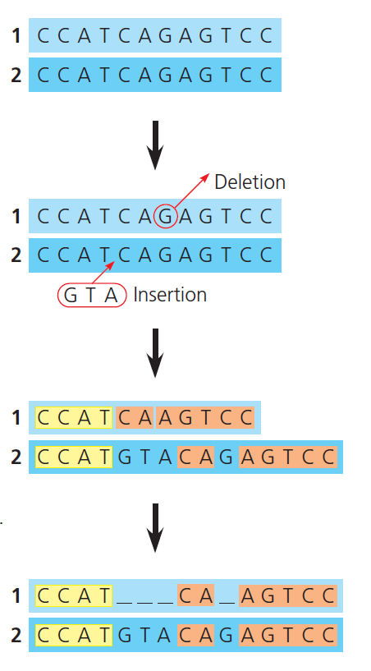**ALIGNMENT OF SEQUENCES**